Shop Nest Dashboard Report
- Top Categories by Total Price

Identify and visually represent the top 10 product categories by total sales.

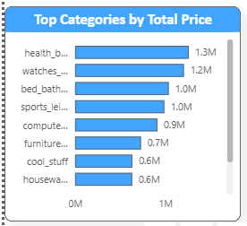
- The highest-selling category is health_beauty with total sales of around 1.3M.
- Other top categories include watches_gifts (1.2M), bed_bath_table (1.1M), and sports_leisure (1.0M).
- Categories such as housewares and cool_stuff contribute lower but still significant sales, around 0.6M – 0.7M.
✅ Insight: Focus marketing campaigns on health & beauty and watches while exploring growth strategies for housewares and cool_stuff.

- Delayed Order Status

Determine the number of delayed orders in each category. An order is considered delayed if the actual delivery date is later than the estimated delivery date.

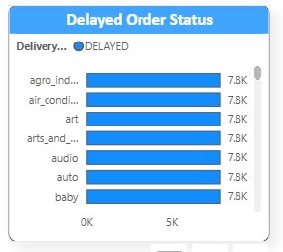
- The majority of delayed deliveries are around 7.8K orders per category.
- Industries like agro_industry, air_conditioning, arts_and_crafts, audio, auto, and baby products show similar delay volumes.
✅ Insight: Investigate logistics and supply chain issues for these categories to reduce customer dissatisfaction.

- Monthly Comparison of Delayed and On-Time Order

Create a dynamic visual that compares the number of delayed orders to the number of orders received earlier for each month. Utilize the drillthrough cross-report feature to provide a detailed analysis of late and on-time deliveries.

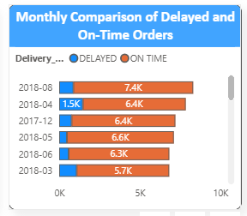
- Delays peaked in 2018-08 (7.4K delays).
- On-time orders are consistently higher (around 60K+ per month).
✅ Insight: Delivery efficiency has improved slightly, but August 2018 was a critical month with maximum delays. Action plan needed to avoid spikes.

- Payment Method Analysis

Analyze the most frequently used payment methods by customers using a visually appealing representation, such as a pie chart or other suitable visuals.

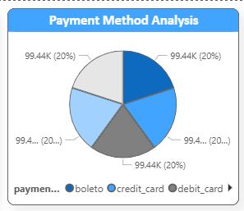
- Payments are distributed evenly across methods:
  - Credit Card ≈ 20%
  - Debit Card ≈ 20%
  - Boleto (bank slip) ≈ 20%
  - Other methods also hold ~20% each.
✅ Insight: Customers prefer multiple payment methods equally, suggesting a need to maintain variety and ensure smooth processing across all.

- Product Rate Analysis

Determine the top 10 highest-rated products and the bottom 10 lowest-rated products using a bar or column chart.

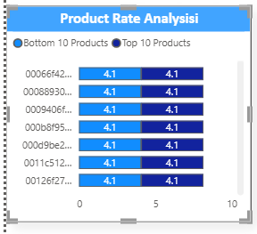
- Ratings show uniform values (4.1 average rating) across products.
- Both Top 10 and Bottom 10 Products maintain almost the same customer satisfaction level.
✅ Insight: Product quality is consistently high, with little variation in ratings.

- State-wise Sales Analysis

Identify and visually represent states with high and low sales, providing a clear understanding of regional sales performance.

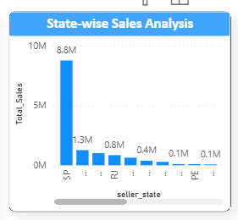
- São Paulo (SP) dominates sales with 8.8M in revenue.
- Other key states: Rio de Janeiro (1.3M), Minas Gerais (0.8M).
✅ Insight: Focus marketing in high-performing states (SP, RJ, MG) while creating campaigns to boost sales in smaller states.

- Seasonal Sales Pattern

Investigate and visualize any seasonal patterns (Quarterly) or trends in sales data over the course of the year.

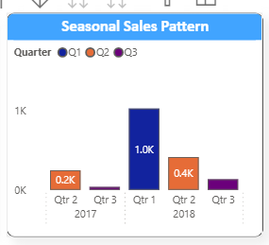
- Q2 2018 recorded the highest sales (1.0K units).
- Q1 and Q3 2017 had much lower sales (~0.2K each).
✅ Insight: Sales peak in Q2, suggesting strong seasonal demand cycles. Target Q2 campaigns to maximize revenue.

- Yearly Revenue Trend

Determine the total revenue generated by ShopNest Store and analyze how it changes over time (Yearly). Represent this information through suitable visuals to highlight trends and patterns.

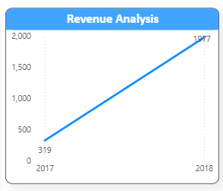
- Revenue increased from 319 (2017) to 1,976.73 (2018).
✅ Insight: Strong year-over-year growth, with more than 6x increase in total revenue. Focus on sustaining this momentum.

Overall Business Insights
- Top categories (health & beauty, watches) should remain the focus.
- Logistics issues in specific categories need improvement.
- Payment flexibility is crucial as no single method dominates.
- Regional concentration in São Paulo highlights growth opportunities in underperforming states.
- Sales seasonality (Q2 peak) should be used for promotions and stock planning.
- Revenue growth trend is very positive and should be sustained with operational improvements.

